**s**

**UNCOVERING THE GAMING INDUSTRY- VIDEO GAMES**

**1.INTRODUCTION:**

This project about the analysis of sales process in video games industry. This is the process of collecting and analysing data about the sales of video games in order to understand market trends and consumer behaviour. This type of analysis can be useful for a variety of purposes , including identifying the most popular games and genres , predicting future sales, and developing marketing strategies. This data may include information about Once the data has been collected, it is typically analyzed using tableau. The results of the analysis can be used to identify trends and patterns in the market, and to make informed decisions about the development and marketing of video games. Video game sales analysis may be conducted by game developers, publishers, retailers, and other industry professionals. It is an important part of the video game industry, as it helps to understand the needs and preferences of consumers and to identify opportunities for growth and innovation.

**2.PROBLEM DEFINITION & DESIGN THINKING:**

**2.1** EMPATHY MAP:

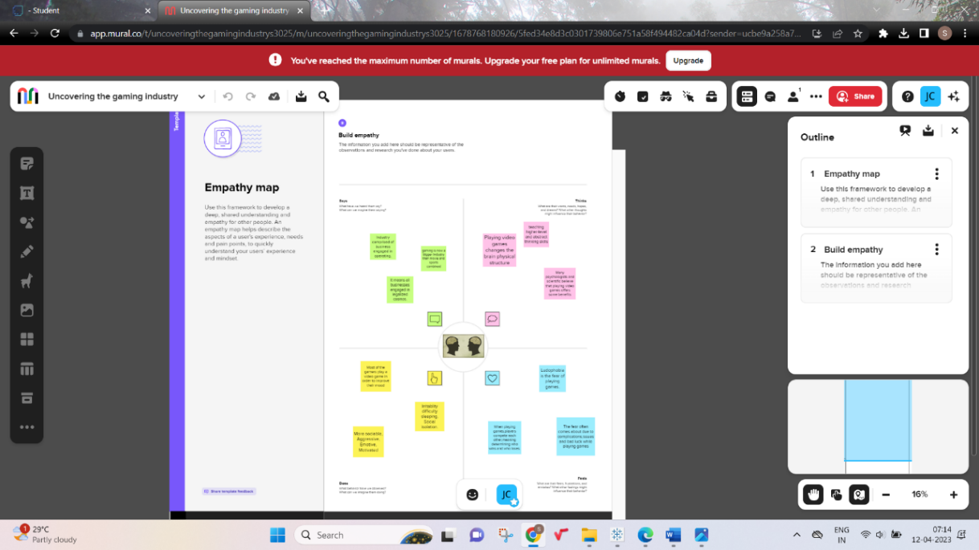

2.2 Ideation & Brainstorming Map:

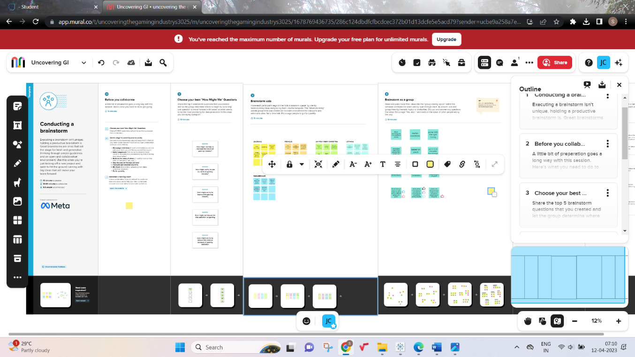

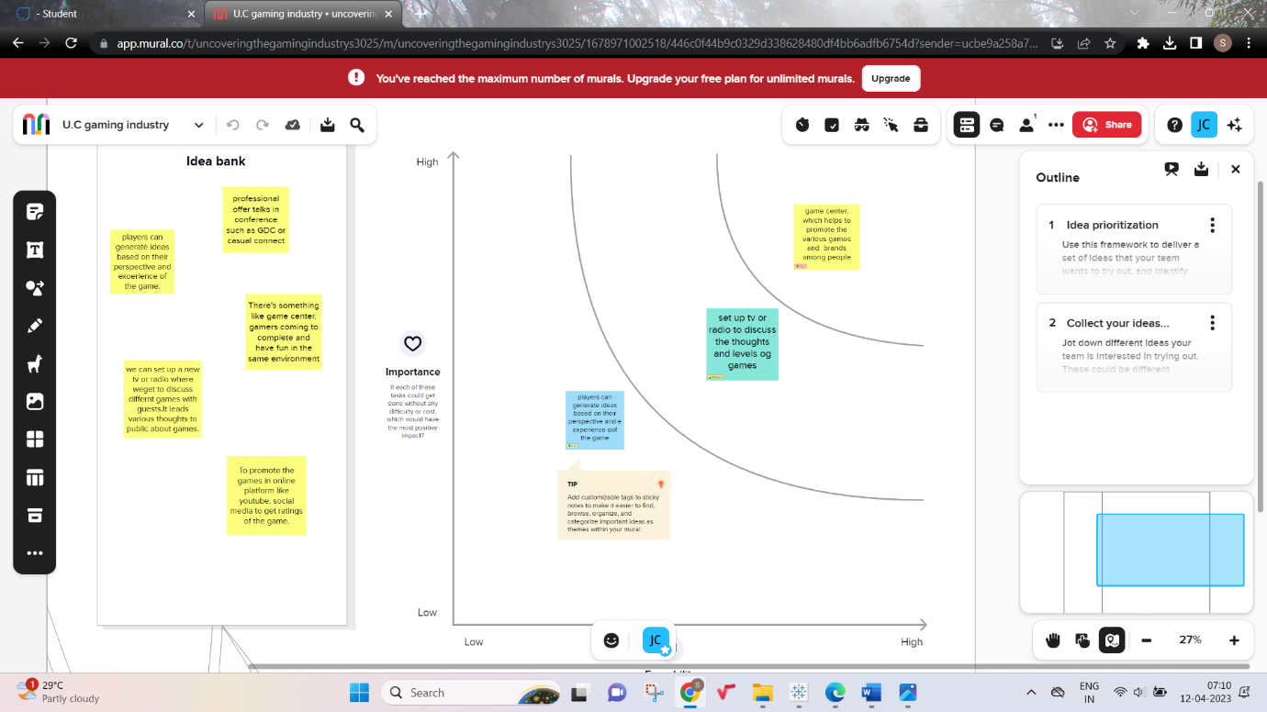

**3. RESULT:**

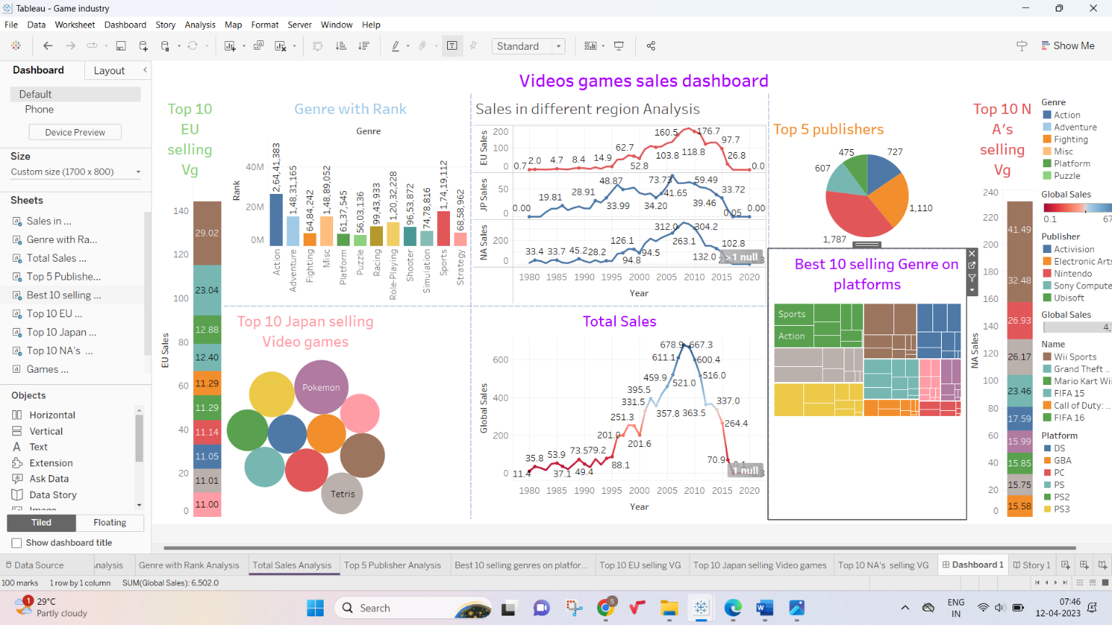

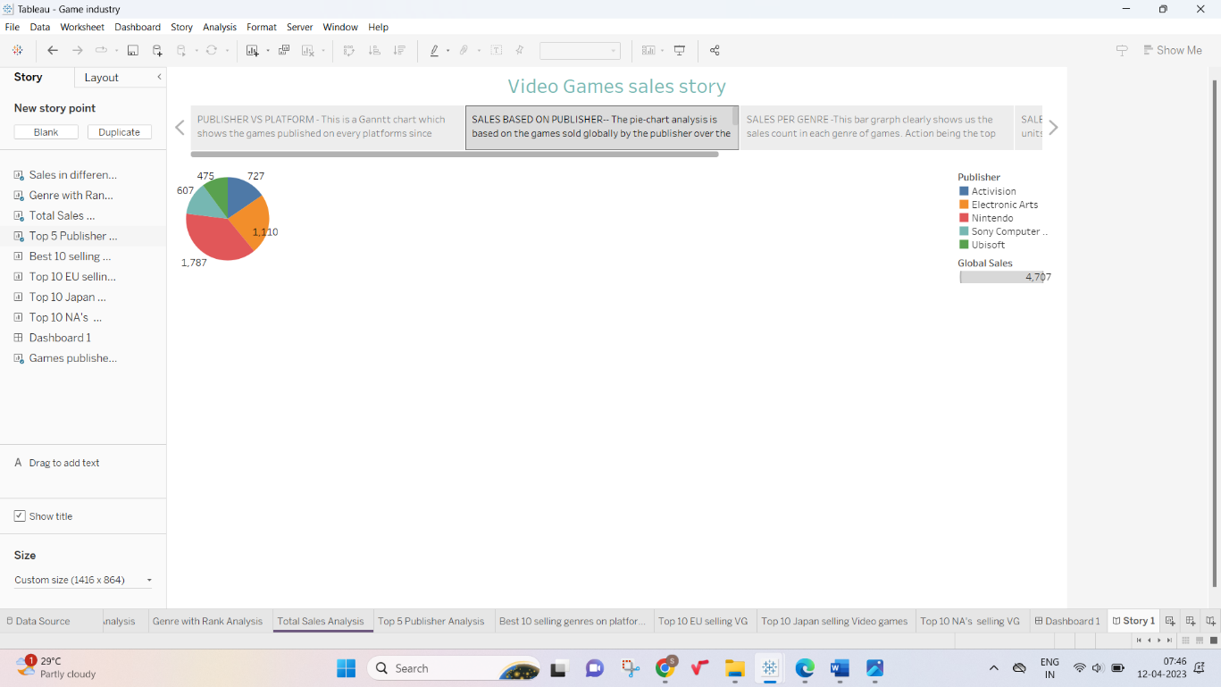

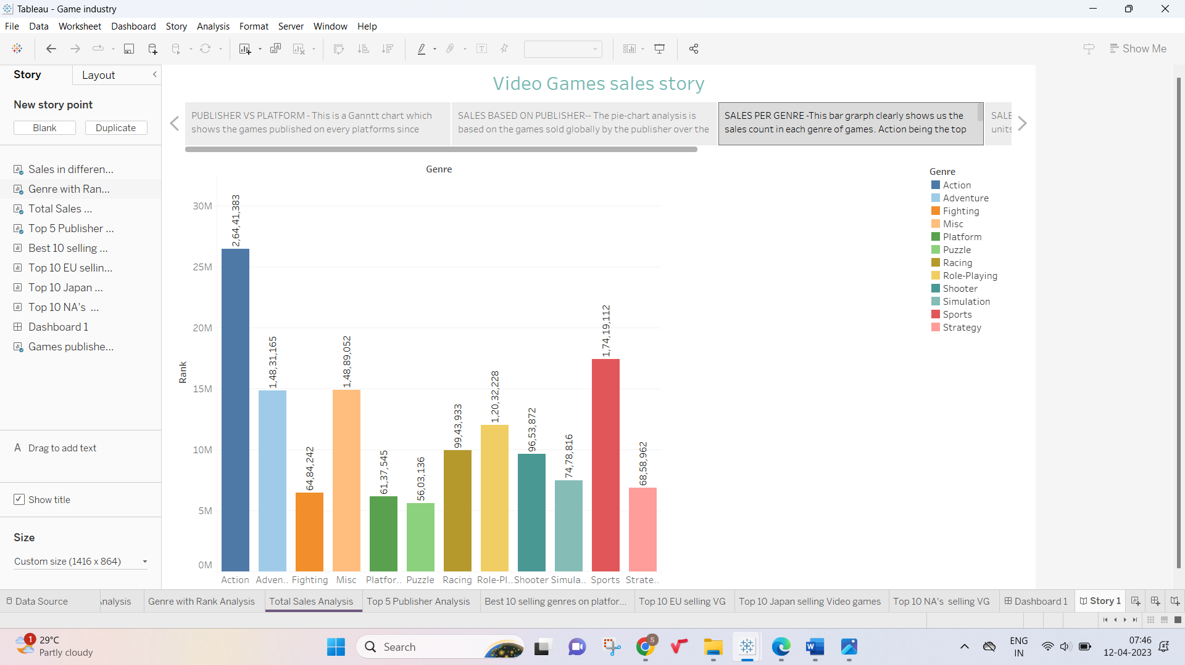

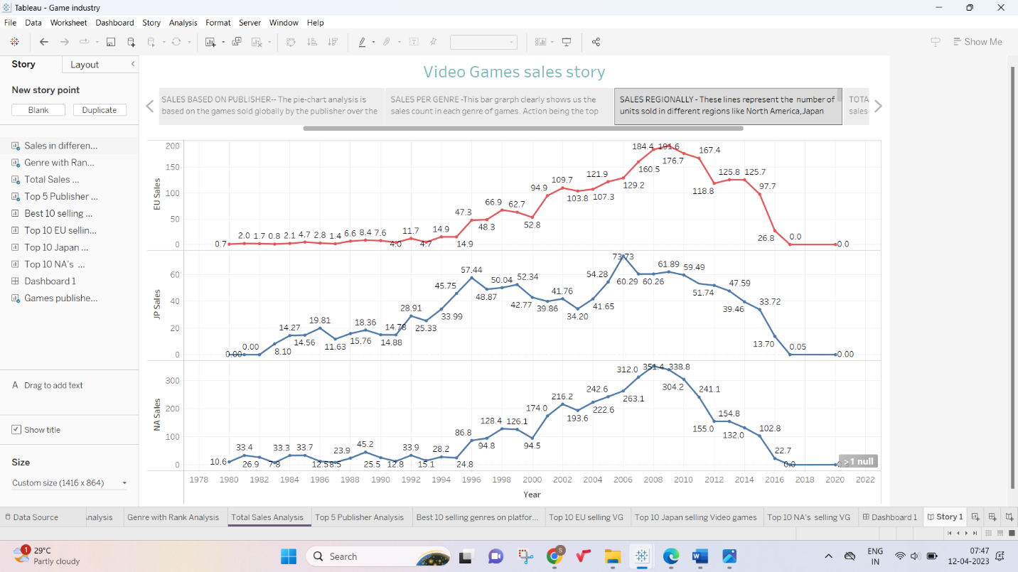

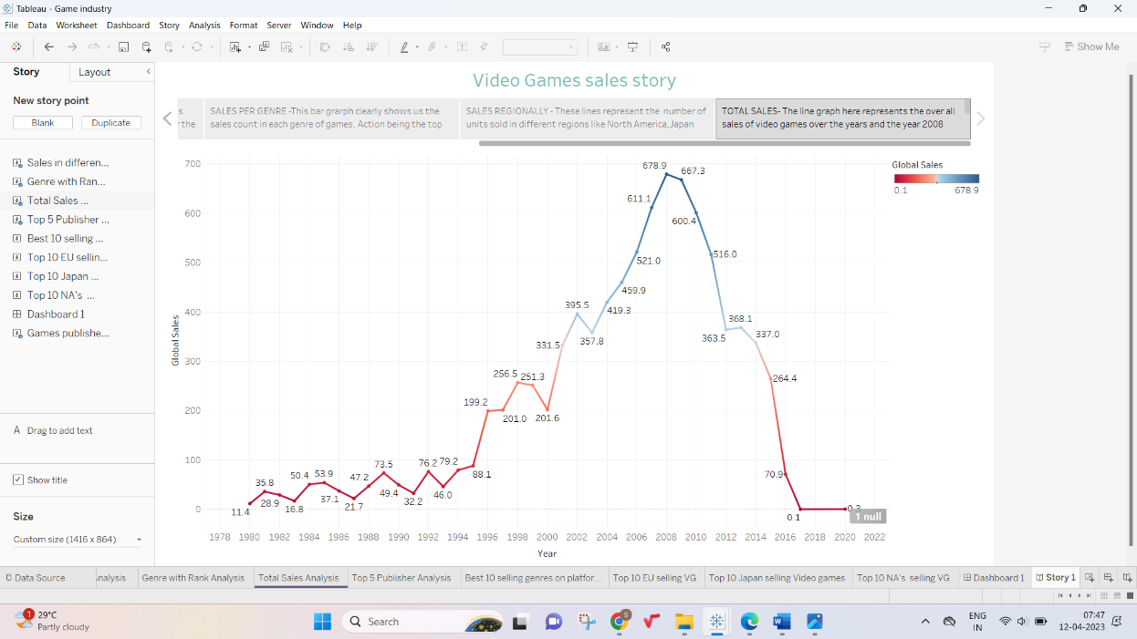

**4. ADVANTAGES & DISADVANTAGES:**

Many parents distrust video consoles and don’t want them in the house because they are afraid that they will damage their children performance at school. However, the benefits of videogames include improved powers of concentration, creativity, memory, languages and team work. Video games can be used to help include test score, teach life and job skills, improve brain function and encourage physical exercises. Because video games addiction can negatively impact social and physical health , parents should be aware of the symptoms. Many video games teach kids how do delegate, work as a team and prioritize. Internet enabled games that let kids play with their real life friends often require collaboration and division of tasks to beat the level. Video games have been shown to help us improve our ability to reason and solve the problems .They help us makes split the second decision , process information more quickly , and multitask effectively games can also improve hand eye coordination and boost auditory perception. violence level, language.

While every other study seems to draw opposite conclusions about the social effects of playing violent video games,  studies involving brain scans are concerning. Simply put, children playing violent video games show decreased activity in areas of the brain dedicated to self-control and an increase in emotional arousal. Even though the debate continues, be aware of how violent games affect your children. If you notice game’s a problem, go with your gut. Help your children choose games you feel are appropriate. Many console game ratings include detailed information about the contents of the, topics, etc.

It’s important to be a able to tell whether video games are negatively affecting or replacing other aspects of your kids lives and also to know exactly how much time they are spending on gaming . Kids who play online games can spend time their friends from the comfort of their bedroom. However, this kind of virtual get together makes a poor replacement for face to face interaction. Another danger is online predators , and then you also have cyber bulling. A virtual hangout stops kids from going to one house to another and stops them being able to practice social skills.

**5.APPLICATION:**

The computer gaming industry has today become bigger than the world music and movie industries. The influence of computer games over the youth of today is akin to that of the cultural influence of music,political movements and even religion on youth cultural of the past . Of late ,computer games have been attracting people of all kinds into using computers . They have driven the spread of computers into the lives of individuals who had earlier had no incentive to use them. Computer games are gaining unprecedented access to the homes ,minds and souls of people today. Hence it has become increasingly important for game developers and educators to study the application of computers for exchanging the education offered to the next generation of students . Computer games can be used to give a better form of education and can even make computers become the unique tools of learning. The paper will present the current scenarios of computer games being used for the purposes of education and training .It will also do well on areas in which the tremendous capabilities of computer games as an education medium can be utilized in educating a new generation of students weaned on computer games. New possibilities for computer games as tools of knowledge will also be projected.

**6.CONCLUSION:**

The results of this project are in agreement with the finding of other studies around the world about the video games sales . This project includes sales in different region analysis, Genre with rank analysis, Total sales analysis ,Top 5 publishers analysis ,Best 10 selling genres on platform analysis, Top 10 EU selling video games analysis ,Top 10 Japan selling video games analysis and Top 10 NA selling video games. This project shows that the NA’s is the most popular region on the selling video games among the other regions.

**7.FUTURE SCOPE:**

The gaming industry has an array of career choices to offer. It makes up for a large segment on the employment front too. According to statistics shared by the American Gaming Association, game industry jobs provide employment to as many as 1.7 million individuals, with the employment rate growing by 62,000 jobs (on average) every year.

The most common myth about **game industry jobs** is the lack of options. However, game careers are not limited to game design and game development. Here are some game industry jobs that you can take up as a profession:

* **Video Game Designer:**

you don’t code and cannot sketch, but you have a million-dollar idea for a game that could be a breakthrough. Well, you are not in for a disappointment. The job of a video game designer is to create a blueprint of the characters and the purpose of the game.

* **Video Game Artist:**

drink some coffee, grab your sketchbook and wake up the artist in you! Video game designers need to work around animated characters to design the game. Here’s where a video game artist’s talent comes into play. So, go ahead and draw your imagination!

* **Writer:**

almost every video game has a background story. Take for instance the popular game, “Marvel Contest of Champions”. The dialogue depiction is a major part of the game and, of course, needs writers. Today, many games incorporate scripts to make the games look more interactive. Moreover, writers are also responsible for the manuals and the in-game menus.

* **Audio Programmer:**

a major element, and one of the USPs of any game, is the background score. Long gone are the days when music was just part of movies and plays. In fact, the sound effects in a game have proven to be as important as the game’s visual appeal. This is where audio engineers play their part in making the gaming experience worthwhile.

### Game Programmer:

to become a video game programmer, you need two things – a knack for coding and a love for video games. For your support, you will need the whole ensemble of the video game designer, writers, video game artists, audio programmer and a slew of other video game professionals. However, you will be responsible for bringing the game to life on a device.

### Game Tester:

Imagine getting paid for playing games? Well, that’s what a game tester has to do - for a living - almost every day! Though it sounds merry and fun, the job of a games tester is not any easier than that of a video game designer or a game developer. Game testers have to pay attention to minute details while playing the game so that they can take notes on the user interface and glitches (in case there are any).

### Professional Gamer:

though it sounds unbelievable, playing games can make you rich. With YouTube videos becoming a major source of income for many, “All play and no work” doesn’t seem like a bad idea at all. The trending “Let’s Play” videos have earned competitive gamers enough to live a comfortable life.

### Game Producer:

It may seem like the industry is run by video games designers and game developers, however, that is not the case. A vital element in getting a video game up and running in the market is the job of a game producer. Game producers are responsible for handling the budget, project management and marketing of video games.

**The gaming industry and its perks**

Financial motivation can drive you ahead in life! The game development industry is known to pay well and is one of the many illustrious professions in the world. Though the salary of a game development professional varies depending on the organisation, we have come up with an estimate. So, before you step into the gaming world, here’s an overview of what your bank balance will look like.  
  
A video game designer and an audio programmer are most likely to not have the same set of skills that are instrumental in a game. However, their worth in the market, in terms of average salary, is estimated to be around £30,000 per annum. A video game artist’s average salary is around £40,000 per annum, while that of a game producer varies from £40,000 to £80,000 depending on the success of the game. A writer’s average income also depends on the game’s success and can go up to £150,000!

It is evident that ***game development careers*** are top-notch, in terms of thrill as well as financially.